Aircraft engine oil check and maintenance platform, 8,15 m platform height.

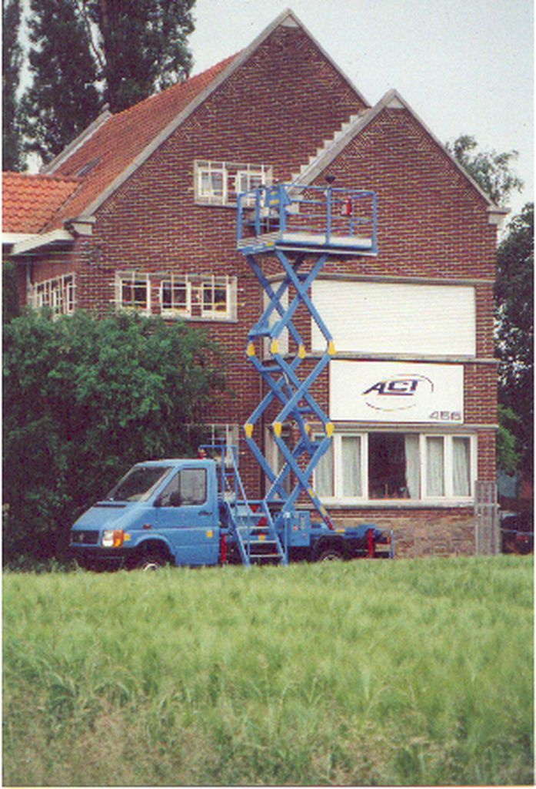

Specifications :

- Basic vehicle: VW Crafter wheelbase 4490, MAN TGE wheelbase 4490, or Mercedes Sprinter wheelbase 4325, Iveco Daily wheelbase 4100, or basic vehicle to customers choice wheelbase 4332, 4.6 tons with PTO ( rear wheel drive) , or basic vehicle to customers choice
- Minimum platform floor height: 1 metre 50
- Maximum platform floor height: 8 metre 15
- Platform dimensions: 1 metre 50 x 2 metre 92
- Payload: 300 kg
- Vehicle width: 2 metre 15
- Vehicle length: 6 metre 80
- Hydraulic system with Rexroth components
- Electronic engine speed control
- Emergency pump
- 4 stabilizers
- Platform lightning by 2 adjustable lights
- The whole construction is painted in aero paint in order to get skydrol resistance
- Fixed entry stair at the front
- Starting and stopping of the engine via the switch box on the platform
- CE approved
- 2 year warranty on parts

Options
- Hydraulic compressor
- 220 Volts inverter of 2500 Watt
- Hydraulic oil filling system for the aeroplanes with barrel accommodation under the stair, pump and hose reel
- Electronic speed limiter with key switch
- Construction to customer specification

